Nilgoun Bahar, PhD SLP
/niːl'ɡuːn bæˈhɒːɾ/
Postdoctoral fellow and paediatric speech-language pathologist at the Dyslexia Center at the University of California, San Francisco (UCSF).
I’m fascinated by how children learn to speak and read, and by how the developing brain supports, or struggles with these skills. My research focuses on the neural and cognitive mechanisms underlying language-based learning disorders. Through this work, I hope to develop biologically informed approaches to early assessment and intervention to help affected children thrive in our chatty, literacy-dependent world. As a clinician, I’m also proud that I am often the one collecting my own data, which gives me unparalleled insight into each child’s profile and the population of children I’ve chosen to work with.
------
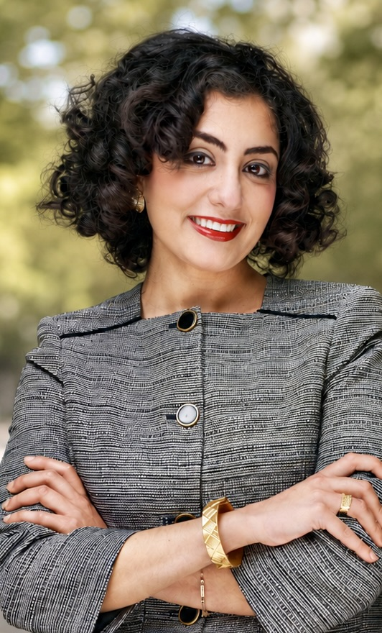
I’m an Iranian-Canadian researcher currently calling the Bay Area home. The common thread running through my interests has always been language. My idea of fun as a teenager was reading Chomsky's Syntactic Structures and discovering that words like daughter and دختر share a common root (goosebumps!). I think about the inferior frontal gyrus, a lot.
I studied Linguistics and Film Studies at the University of British Columbia, with a minor in Spanish. I moved to Toronto in 2019 to start a Master's degree in Speech-Language Pathology at the University of Toronto. During my clinical placements, I was struck by how readily we look to the brain when language breaks down in adults yet how rarely we do so when children struggle with learning language. That led me to reach out to Professor Kate Watkins at the University of Oxford, one of the few researchers at the time to have secured funding for a large-scale, multimodal investigation of developmental language disorder (DLD), integrating behavioural and brain imaging methods. I spent the next three years at Oxford as her PhD student, co-supervised by Profs Kate Nation (Oxford) and Saloni Krishnan (University College London), learning neuroimaging, neuroanatomy, and how to turn broad ideas into testable hypotheses.
My PhD focused on the behavioural and neural correlates of DLD, including a longitudinal study of myelin development in a subset of these children. My first paper from the thesis, published in Neurobiology of Language, showed that children with DLD had reduced cortical surface area in language- and reading-related cortical regions, and that smaller surface area was associated with poorer language ability. I later used functional MRI to investigate the role of frontostriatal circuitries in novel word-form learning in DLD, and, in another project, how dopaminergic reward systems are associated with learning words from written context in children with dyslexia.
In 2025, I moved to San Francisco to join Dr. Maria Luisa Gorno-Tempini's lab and the UCSF Dyslexia Center as a post-doctoral researcher, through the UCSF–UC Berkeley Schwab Program. I continue to study DLD and dyslexia using multimodal neuroimaging and in-depth cognitive phenotyping, with a broadened interest in how attention and executive functions interact with oral and written language systems. My recent work has examined the cognitive and white-matter mechanisms underlying the co-occurrence of dyslexia and ADHD. I also contributed to data-driven approaches for identifying cognitive subtypes of dyslexia. I am currently designing a new fMRI paradigm to assess the neural correlates of phonological vs. morphological awareness in struggling learners.
I also have a soft spot for speech motor control. During the pandemic, I co-authored a review paper with Dr. Aravind Namasivayam and Prof. Van Lieshout on telehealth treatment for childhood apraxia of speech to help clinicians navigate the sudden shift to remote therapy. More recently, I contributed to a paper arguing that many of the categories we use to classify childhood speech sound disorders may reflect the limits of human perception rather than the continuous nature of speech motor development. I believe this perspective will shape the future of how we treat speech disorders in children.
When not working, I dance Argentine tango. It's not so different from language development. You begin by learning the building blocks, the individual steps, much like babbling speech sounds. Those combine into familiar movement patterns, just as sounds combine into words, until eventually you're able to string them together into longer, fluid sequences. With enough practice (and far longer than it takes children to learn language), technique fades into the background, opening room for subtlety and a chance to converse with another person on the dance floor.
Naturally, my tango obsession comes with the culture attached; I bake alfajores when I'm craving something sweet and spend most evenings sipping on yerba mate.

Teaching & Mentorship
My teaching experience comes from the University of Oxford, where I taught as a tutor within the University's tutorial system.. Oxford tutorials are weekly, small-group teaching sessions (typically one to three students) that complement lectures through guided discussion. Tutorials revolve around essays, research papers, or problem sets prepared in advance, with the tutor responsible for planning the session, leading discussion, challenging students' ideas, and providing detailed feedback on their written work.
Between 2022 and 2024, I tutored the following undergraduate courses:
- Introduction to Cognitive Psychology
- Psychology of Language
- Developmental Science
- Neurobiology of Speech & Language

I also worked as a teaching assistant for Cognition Core Practicals and fMRI: Experimental Design & Analysis, where I supported students with experimental design, statistical analyses, coding, and essay writing and assessment.
My current position at the UCSF is centered on clinical work and research rather than teaching. I do, however, enjoy mentoring students and currently supervise summer research interns as well as an undergraduate student completing her honour’s thesis in our lab.
Invited Lectures
I’ve given lectures to students, researchers, and clinical audiences at a number of universities and professional organisations, including:
- The Neurobiology of Developmental Language Disorder — Language & Literacy Lab (Dr Ioulia Kovelman), University of Michigan (2026)
- Dyslexia and ADHD in Children: Neurocognitive Mechanisms of Co-occurrence — Gabrieli Lab (Dr John Gabrieli), MIT (2025)
- Understanding Developmental Language Disorder: Brain & Behaviour — Paediatric Neuropsychology Course, University College London (2025)
- Understanding Developmental Language Disorder: Brain & Behaviour — Sussex Speech and Language Consortium (2024)
- Developmental Language Disorder: From Biology to Clinical Practice — Royal College of Speech and Language Therapists Clinical Excellence Network (2023)
- An Introduction to Conducting Systematic Reviews — M.S. Speech-Language Pathology Program, New York University (2022)

20 European postdoctoral fellowships worth bookmarking.
1. MSCA Postdoctoral Fellowships
→ The gold standard. Open to all fields.
🔗 https://lnkd.in/d6pUheS5
2. Alexander von Humboldt Fellowship (Germany)
→ Rolling applications, no fixed deadline.
🔗 humboldt-foundation.de
3. EMBO Postdoctoral Fellowships
→ Life sciences only.
🔗 https://lnkd.in/dUK87vbQ
4. HFSP Postdoctoral Fellowships
→ Highly interdisciplinary.
🔗 https://lnkd.in/dDWGKh29
5. EMBL ARISE Fellowships
→ Research infrastructure and technology development.
🔗 embl.org/about/info/arise
6. Swiss Government Excellence Scholarships
→ Fully funded. Application goes via Swiss embassies with country-specific deadlines.
🔗 sbfi.admin.ch (search: Excellence Scholarships)
7. ETH Zurich Postdoctoral Fellowship
→ Internal fellowship. Host at ETH required. Explicitly aimed at career acceleration towards independence.
🔗 https://lnkd.in/d6qGwsuh
8. EPFL Excellence Postdoctoral Fellowships
→ Host at EPFL required. Strong emphasis on novel directions.
🔗 https://lnkd.in/dP52iArc
9. SNSF Swiss Postdoctoral Fellowships
→ Check each call for mobility options.
🔗 snf.ch
10. Wellcome Early-Career Awards (UK)
→ Life sciences and adjacent fields.
🔗 https://lnkd.in/d2NfGMnx
11. British Academy Postdoctoral Fellowships
→ Humanities and social sciences focus. Often overlooked by STEM researchers.
🔗 https://lnkd.in/dKRSeyBr
12. Leverhulme Trust Early Career Fellowships
→ UK-based. Host required. Unconventional, quirky research encouraged.
🔗 https://lnkd.in/dQu7bmtW
13. Research Ireland Postdoctoral Fellowship
→ Ireland-based host required. Check current calls as branding evolves.
🔗 researchireland.ie
14. Novo Nordisk Foundation Fellowships (Denmark)
→ Broad biomedicine and life sciences focus.
🔗 https://lnkd.in/dn3WFtzt
15. Carlsberg Foundation Fellowships (Denmark)
→ Less known internationally. Covers natural sciences and humanities.
🔗 carlsbergfondet.dk/en
16. Wenner-Gren Foundations Fellowships (Sweden)
→ Swedish or Swedish-connected research. Strong in natural sciences.
🔗 swgc.org
17. Wallenberg Academy Fellows (Sweden)
→ Prestigious. Long-term funding. Highly competitive.
🔗 https://lnkd.in/dDmXAJWH
18. FCT Postdoctoral Fellowships (Portugal)
→ Portugal is investing heavily in research.
🔗 fct.pt/en
19. CNRS Postdoctoral Opportunities (France)
→ France's national research system. Positions listed continuously, multiple entry points throughout the year.
🔗 emploi.cnrs.fr
20. Choose Europe Initiative
→ EU-backed push to attract global researchers.
🔗 https://lnkd.in/dkq3hKBc
If you are interested in some of these programs, please connect and inbox me for more information
My undergraduate thesis explored how Terrence Malick (my favourite filmmaker) uses voice-over narration to convey meaning beyond imagery. For my Spanish final project, I compared three Farsi translations of Federico García Lorca's La casa de Bernarda Alba, showing how moving words between languages can act as a political tool to reshape ideas.

